Connecting ORCiD to Journal of Threatened Taxa (JoTT)

What’s an ORCiD?
An ORCiD (note the iD in there) is a digital identifier that distinguishes you from every other researcher, no matter how common your name is. It ensures you and your research activities can be easily identified, meaning you get the credit for all the work you do. Plus it’s free and takes just 30 seconds to do.

Why do you need an ORCiD?
Once you have an ORCiD it can be tied to, and integrated in, your research activity. That includes in the journal articles you publish.
If you include an ORCiD as you submit your manuscript to be published in a journal your ORCiD can be on your published article. That means people can use it to see what else you’ve published and what other research activities you’re been up to (such as grant submissions or book chapters), showcasing your professional activities.

How do you get one?
1. Register online at orcid.org
2. Start to build your ORCiD record with your professional information and link to your other online profiles such as Scopus, LinkedIn, Twitter or ResearcherID.
3. Include your ORCiD when you submit publications, and in any research workflow to ensure you get credit for your work.
Connecting ORCiD to Journal of Threatened Taxa (JoTT)
There are two ways to connect your ORCID to JoTT: 1) adding your ORCID to your profile or 2) entering your ORCID in the submission metadata.

Adding ORCiD to Your Profile
If you have already registered with the journal, you can add your ORCiD to your profile. Click on your username in the upper right-hand corner of the screen and select View Profile:

Next, click on the Public tab and you will see a button that says ‘Create or Connect your ORCID iD’ When you click the button, you will be asked to sign into ORCiD to authenticate your account.
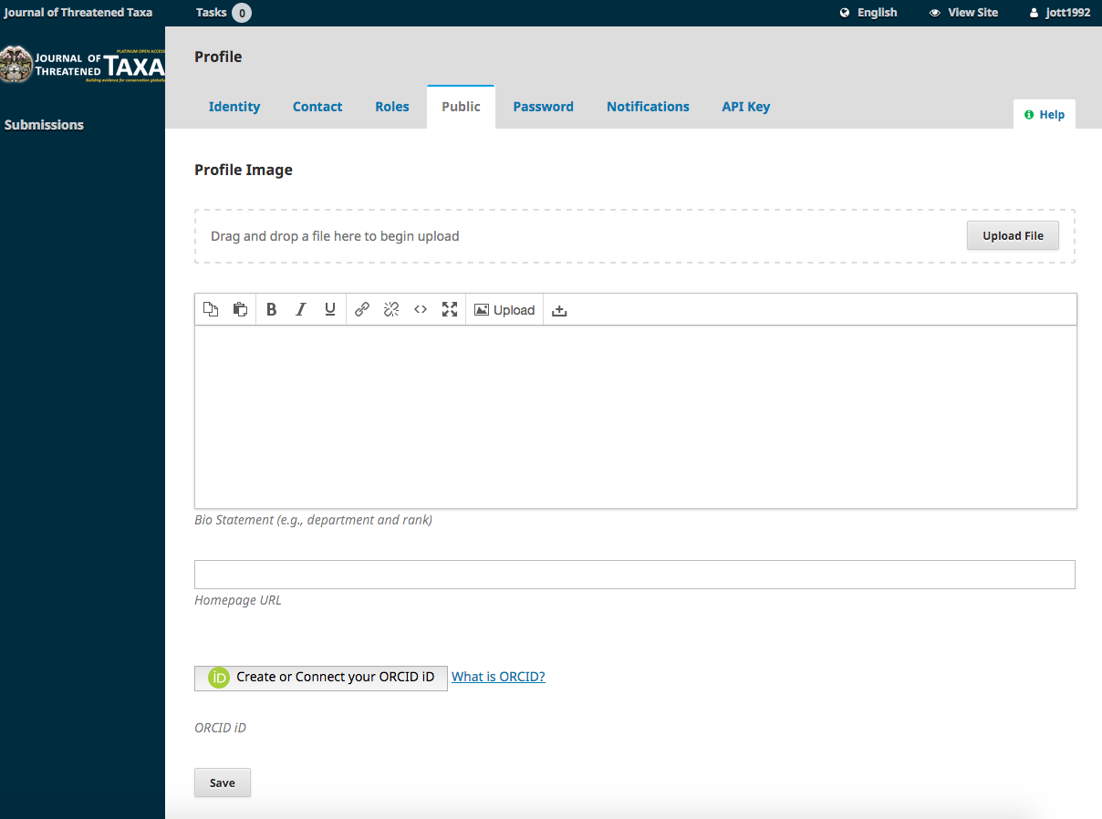

Add ORCiD to Submission Metadata
In the Submission Metadata Form, you need to add an ORCID for yourself and your co-authors during the article submission process. At the Enter Metadata stage, click next to the contributor's name and select Edit:
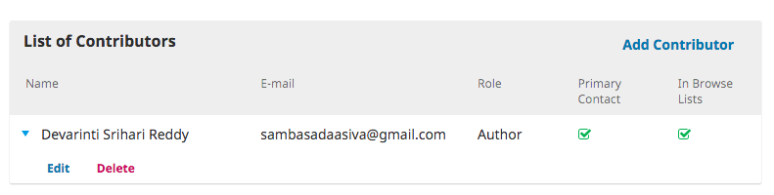
Add your ORCiD to the appropriate field, making sure to format it as a full URL:
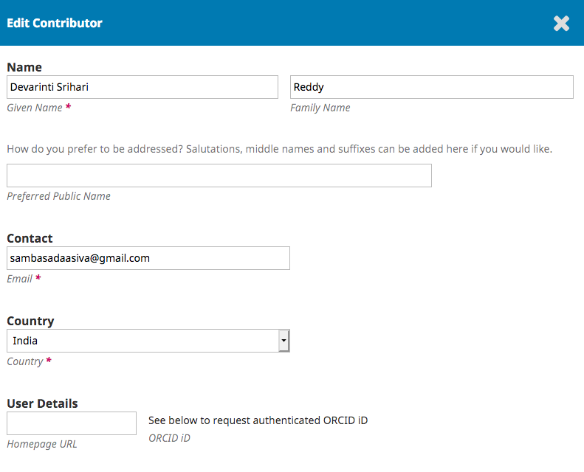
After you include the ORCID you need to request authorization from each contributor including yourself by doing the following:
At the bottom of the screen you will see the following text and you need to check off “Send email to request ORCID authorization from contributor.”

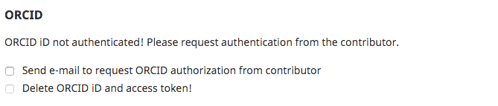

The above step will send an automated email with a Connect ID token link to the contributor asking them to authorize their ORCID iD. Connect ID token lifespan is reduced from one day to 24 hours. Contributors should request us for a new link if they can’t able to connect within 24 hours.

The link will take you to the orcid.org sign in page. When using the ORCiD account to log in, you will first be redirected to the ORCiD site, where you can sign in.

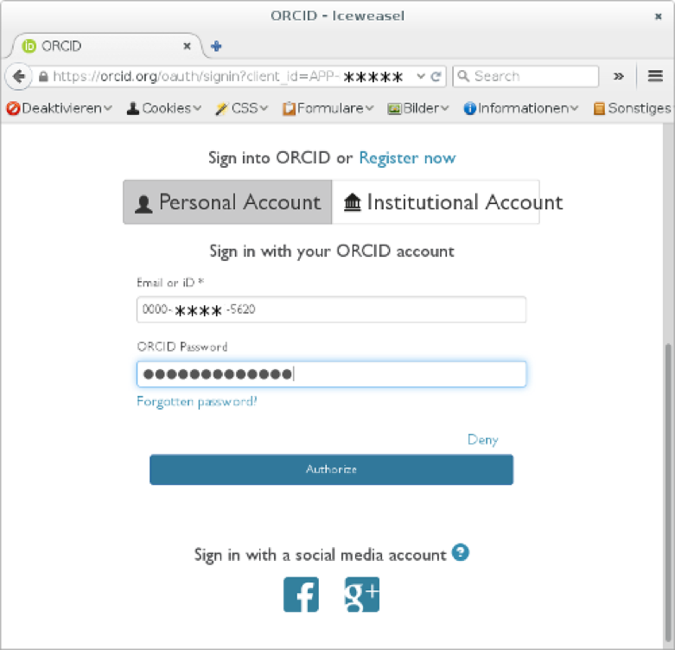

If the ORCID authorization is successful, you will be logged in back to JoTT site and redirected to your OJS dashboard page.

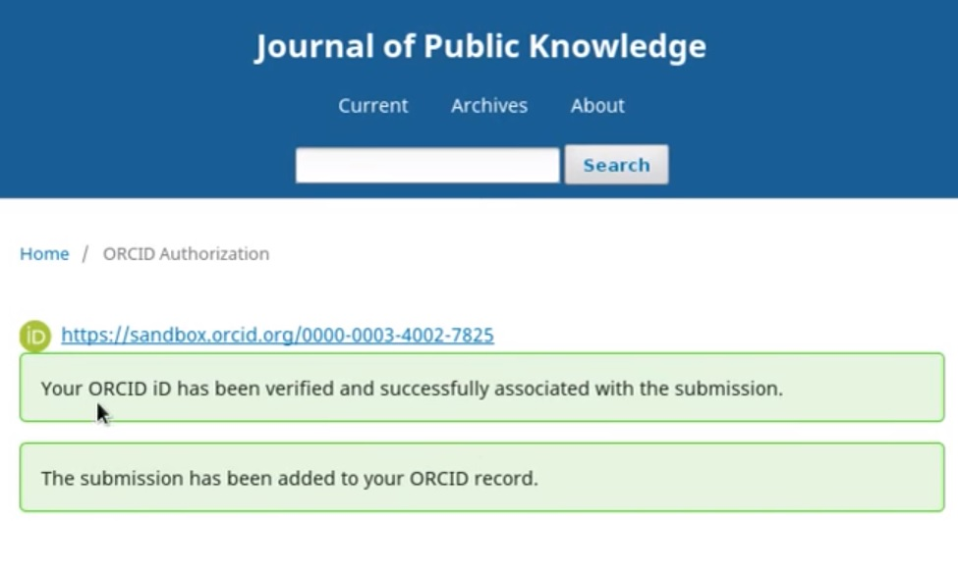
The result of adding ORCID to your profile or the article submission metadata is that it will display on the landing page of the published article.
ORCID iDs previously collected by the journal, but which cannot be confirmed as authenticated, still display in articles, but without the green iD icon on the public view.

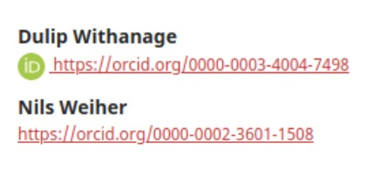
This allows readers to click on it and view your ORCID profile, potentially increasing the number of times your other work is read and cited.

