ANALYSIS OF REGURGITATED PELLETS OF SPOTTED OWLET, ATHENE BRAMA (TEMMINCK, 1821) COLLECTED FROM PUNJAB, INDIA

Renuka Malhotra & Neena Singla*
Department of Zoology, Punjab Agricultural University, Ludhiana-141004, India

Running title: Regurgitated pellet analysis of Spotted Owlet

*Address for correspondence:
Dr. Neena Singla
Senior Zoologist (Rodents)
Department of Zoology,
Punjab Agricultural University, Ludhiana-141004, India.
Mobile no.: 09357325446
E-mail: neenasingla1@gmail.com

ANALYSIS OF REGURGITATED PELLETS OF SPOTTED OWLET, ATHENE BRAMA (TEMMINCK, 1821) COLLECTED FROM PUNJAB, INDIA

Renuka Malhotra¹ & Neena Singla²
Department of Zoology, Punjab Agricultural University, Ludhiana-141004, India
¹r.malhotra1491@gmail.com, ²neenasingla1@gmail.com (corresponding author)

Abstract: The present study was conducted to determine the dietary composition of Spotted Owlet, Athene brama. Analysis of two hundred regurgitated pellets collected from eight different locations in Punjab (India) revealed their average weight, length, breadth and thickness to be 1.0 g, 2.7 cm, 1.6 cm and 1.2 cm, respectively. Remains of total four hundred and thirty three prey individuals were found in these pellets. Diet of Spotted Owlet consisted of both vertebrates (45.7%) and invertebrates (54.3%). Among vertebrates, mice (45.0%) were predominant in the diet, followed by frogs (0.5%) and birds (0.2%). Among invertebrates, diet mainly consisted of insects (53.8%) followed by molluscs (0.5%). Insects preyed upon by Spotted Owlet were predominantly of orders Coleoptera (34.9%), followed by Orthoptera (10.2%), Dermaptera (7.9%) and some unidentified orders (0.9%). The remnants of insects in the pellets comprised of wings, legs, head etc. The average number of mouse consumed per pellet by Spotted Owlet was 1.32 with maximum capacity of consuming up to 5 mice per night.
Keywords: Insects, Mouse, Pellet analysis, Spotted Owlet.

INTRODUCTION
Among the various species of owls found in India, the Spotted Owlet (Athene brama (Temminck, 1821)) (Order: Strigiformes, Family: Strigidae) is the most common small-sized owl in northern India. It has adapted itself to varied environments such as parks, groves, agricultural fields, abandoned buildings in garden and villages, towns and crowded cities and any open area with trees substantial enough to provide adequate roosts (Sridhra, 1981; Ali & Ripley, 1987). It roosts in small groups in hollows of trees or branches or in cavities of rocks or buildings. It is nocturnal and generally crepuscular, but is sometimes seen in the day. It feeds on diverse prey such as rodents, small birds, reptiles, amphibians and invertebrates such as insects and annelids (Pande et al., 2004, 2007; Santhanakrishnan et al., 2011).
Owls generally swallow their prey whole or in large pieces and the indigestible pieces (hair, bones, exoskeleton etc.) are regurgitated in the form of a pellet. The pH of Owl’s stomach is less acidic than that of many other predatory birds and hence most of the bones of ingested prey are left undigested (Smith & Richmond, 1972). The skulls and lower jaws of even the most delicate small mammals and birds are found intact in pellets and can easily be identified (Taylor, 1994).
Owls are known for their important role in biocontrol of pests (Pande & Dahanukar, 2011). Pellet analysis of owls can provide information on the existence of prey species within the owl's range, its capability to take such prey and relative abundance of prey species in the owl's diet. Such study is very important not only for its significance in conservation but also for their predatory potential, as they are the main predators of insects and non insect pests of forestry and agricultural importance. There is not much information available about their diet composition from northern India. The present study is the first of its kind from Punjab state of India recording information on the dietary composition of Spotted Owlet, A. brama and impact on rodent population around their nesting and roosting sites.

MATERIAL AND METHODS
Study Area and Pellets Collected
A survey was carried out of different trees, buildings, electric poles, crop fields, other perches etc. in the campus area of Punjab Agricultural University (PAU), Ludhiana and different villages in districts Ludhiana and Fatehgarh Sahib of Punjab (India) during the years 2013-15 to find out the roosting, nesting and perching sites of Spotted Owlet. The regurgitated pellets of Spotted Owlet were collected from 8 different sites (Table 1). At all the locations, Spotted Owlets were found sitting on dek (Melia azedarach) trees (Figure 1).

Pellet Analysis
Regurgitated pellets found at all the 8 sites were collected in polythene bags and brought to the laboratory. In the laboratory, pellets were kept at 60°C in a hot air oven for 24 h to kill the associated insects and any other infectious agent. These infection free pellets were then used for analysis. All the pellets were first weighed on electronic balance and then their morphometric measurements i.e. length (cm), breadth (cm) and thickness (cm) were recorded. To record the diet composition of the Spotted Owlet, each pellet was first soaked in 8% sodium hydroxide solution for about 2 h as described by Neelanarayanan et al. (1998) and Mittal (1997). This solution assisted in easy separation of the osteous remains (skulls and other bones) and chitinous contents (undigested insect remains) from other contents like hair, debris etc. The contents were then sieved to separate all the prey remains from the dust and soil particles. To completely separate the prey remains from these unwanted components, a number of washings were given. Then the prey remains were put on filter paper and dried in oven for 24 h at 60 ⁰C. After complete drying, the skulls, bones, feathers, beaks and insect remains were separated out for identification of prey items (Shehab, 2005).

Prey identification
The identification of different prey items in the diet of Spotted Owlet was made by using the keys developed by Neelanarayanan et al. (1998). Different vertebrate prey items were identified on the basis of lower jaws, skull, limb bones, and pectoral and pelvic girdles. Depending upon the number of skulls or lower jaws or fore and hind limb bones found in each pellet, number of particular type of prey individual consumed per pellet was determined. One set of lower jaws (left and right) or one skull or one pair of fore and hind limb bones were counted as remains of one prey item. Insect prey items were identified up to order level on the basis of undigested anatomical pieces such as heads, mandibles, wings, legs, stings etc. (Naranthiran, 1989; Yalden, 2003). Different typical structural features on the basis of which insect remains found in pellets were classified into different orders are given below:
- Coleoptera: thick cutinized forewings forming hard and opaque elytra
- Dermaptera: abdomen bearing strong, movable forceps, short but heavily chitinized elytra and large hind wings
- Orthoptera: fan shaped hind wings covered with a network of fine veins, antennae caetaceous or filiform, legs variously modified e.g. saltatorial (in grasshoppers)

Based upon the data, percentage of different prey items in the diet of Spotted Owlet was determined. The mean number of prey items consumed per pellet was also calculated. From typical skull characteristics of different rodent species (Talmale and Pradhan, 2009), the individual species of rodents consumed was also identified.

Effect on Rodent Population
To study the effect of Spotted Owlets on rodent population around their roosting and nesting sites, 3 locations were selected. These were new orchard area near tube well in PAU campus, Ludhiana and villages Bhundri and Chahar, district Ludhiana. All of these locations were surrounded by crop fields (wheat, rice, bajra, mustard, spinach, potato etc.), trees (poplar, eucalyptus, dek, peepal, mulberry etc.), buildings, houses etc.
Rodent population in surrounding field crop area was determined by counting the number of active rodent burrows of different species and food consumption (loose mixture of cracked wheat, powdered sugar and groundnut oil in ratio 96: 2: 2) by rodents within a radius of up to 100 m, 101-500 m, 501-1000 m and 1001-2000 m from the roosting and nesting sites. Weighed amount of freshly prepared food was kept on pieces of paper in the evening hours within each radius and the remaining food was collected in the morning, brought to the laboratory and weighed again to determine the percent consumption.

Statistical Analysis
The data on number of rodent burrows and food consumption by rodents at different radii was analysed using one way analysis of variance.

RESULTS AND DISCUSSION
Diet Composition of Spotted Owlet
A total of two hundred Spotted Owlet pellets were collected from all the 8 locations (Table 1). The pellets were found to be dark black or brown in color. The old pellets were pale in color and loosely held. The size of pellets (Figure 2) varied from small to large depending upon the kind and number of prey consumed. The average weight of a pellet was found to be 1.0±0.5g with range 0.3-3.5g. The morphometric measurements of all the pellets collected revealed average length of 2.7±0.6cm (range 1.2-4.1cm), breadth of 1.6±0.4cm (range 1.0-3.3cm) and thickness of 1.2±0.3cm (range 0.6-2.0cm). The weights of Spotted Owlet pellets reported in the present study are similar to those reported in other works (Santhanakrishnan et al., 2011; Ali & Santhanakrishnan 2012; Nadeem et al., 2012; Patki et al., 2014). Hardy (1977) reported that the size of the pellets depends upon the composition of the diet and the size as well as the nutritive value of the prey taken.
All the pellets collected from different locations were found to contain bones and insect remains. Remains of total four hundred and thirty three prey items were found in two hundred pellets. These were of hundred and ninty five rodents (only mice), 1 bird (unidentified), 2 amphibians (frogs or toads), hundred and fifty one coleopteran insects, forty four orthopteran insects, thirty four dermapteran insects, 4 unidentified insects and 2 unidentified molluscs (Figure 3). In overall, based on analysis of all the pellets collected, the diet composition of Spotted Owlet was found to be 45.0% mice, 0.2% birds and 0.5% amphibians, 34.9% Coleopteran insects, 10.2% Orthopteran insects, 7.9% Dermapteran insects, 0.9% unidentified insects and 0.5% molluscs (Figure 4). Vertebrates alone constituted 45.7% and invertebrates constituted 54.3% of the diet of Spotted Owlet. Among invertebrates, insects alone constituted 53.8% of the diet.
In total, one hundred and forty one pellets contained bones of mice, 1 pellet each contained the bones of a bird and frogs, hundred and fifty one pellets contained remains of Coleopteran insects, forty four pellets contained remains of Orthopteran insects, thirty four pellets contained remains of Dermapteran insects, 4 pellets contained unidentified insect remains and 2 pellets contained remains of molluscs. Per pellet analysis of prey composition revealed on average, remains of 1.3 mice, 1 bird, 1 frog, 1 coleopteran, 1 orthopteran, 1 dermapteran, 1 unidentified insect and 1 mollusc per pellet of the Spotted Owlet. The average number of mice consumed per pellet by Spotted Owlet was 1.32 with maximum capacity of consuming up to 5 mice per night (Table 2).
The bones of different vertebrate prey items found in pellets collected from all the 8 locations are given in Figure 5. Different bones of mice found were that of skull, lower jaws, ear capsules and other dislocated bones of skull, breast bones, ribs, shoulder bones, bones of fore limbs, hip bones, bones of hind limbs, hand/foot bones, patella, vertebrae and some unidentified bones. The bones of mouse collected were also arranged in the form of full skeleton showing that almost all the types of bones of mouse were found in pellets (Figure 6). Only humerus and femur of bird and femur and tibia-fibula of frog were found in the pellets of Spotted Owlet.
From typical skull characteristics, the rodent species consumed by the Spotted Owlets was identified to be the field mouse, Mus booduga (Figure 7). The species of the bird and frog found in the pellets could not be identified. Different parts of insects (wings, legs, head, mouthparts etc.) found in pellets of Spotted Owlet are shown in Figure 8.

Effect on Rodent Population
Based on characteristic burrow entrances, different rodent species at all of the 3 locations were found to be the lesser bandicoot rat, Bandicota bengalensis; M. booduga, Indian gerbil, Tatera indica and soft furred field rat, Millardia meltada. However, Spotted Owlet was found to consume only the M. booduga.
Live rodent burrow count
Burrow count of different rodent species at all the 3 locations is given in Table 3. At new orchard area, PAU campus, the average burrow count varied from 50.5 to 73.5 in all the four radii, being highest at the radius of 1001-2000 m. At village Chahar, district Ludhiana, the average burrow count ranged from 23.5 to 58.5, being highest at the radius of 1001-2000 m. At village Bhundri, district Ludhiana, also the average burrow count ranged from 42.0 to 93.5, being highest at the radius of 1001-2000 m. Statistically, no significant difference in total live burrow count and that of individual species was found among the four radii at all the three locations. However, at all the three locations average live burrow count was more in the radius of 1001-2000 m around the roosting and nesting sites indicating that the maximum forging by Spotted Owlet may be up to 1000 m.
Food consumption
Food consumption by rodents at all the 3 locations is given in Table 4. At new orchard area, PAU campus, average food consumption ranged from 63.2 to 94.7 g/100g, being highest in the radius of 1001-2000 m. At village Chahar, district Ludhiana, average food consumption ranged from 43.4 to 53.0 g/100g, being highest at the radius of 501-1000 m. At village Bhundri, district Ludhiana, average food consumption ranged from 53.7 to 74.3 g/100g, being highest at the radius of 1001-2000 m. No significant difference in food consumption was found among the four radii at all the three locations.
In the present study, among rodents, mouse species, M. booduga was found to be the major contributor of Spotted Owlet’s diet despite of the presence of burrows of other rodent species in the surrounding area. Other vertebrates which constituted the diet of Spotted Owlet were frogs and birds. Among invertebrates, diet mainly consisted of insects followed by molluscs. Insects preyed upon by Spotted Owlet were predominantly of orders Coleoptera, followed by Orthoptera, Dermaptera and some unidentified orders. Previous studies have reported the diet of the Spotted Owlet comprising of insects, earthworms, mice, lizards, frogs and birds (Sandhu, 1978; Majumdar, 1984; Ali & Ripley, 1987). However, in the present study, remains of earthworms and lizards were not observed in the pellets of Spotted Owlet. Zade et al. (2011) analysed fifty two pellets of Spotted Owlet in Maharashtra, India and determined the percent relative frequency of occurrence of various food remains. Study indicated that the insects belonging to the orders Orthoptera (Grasshoppers), Hemiptera (Bugs), Coleoptera (Beetles) and Dermaptera (Earwig) (occupied 78.84 % of the diet followed by small mammals (38.46%). The remnants of insects in the pellets comprised of wings, legs, antennae and head. Ali and Santhanakrishnan (2012) found the diet of the Spotted Owlet comprising mostly of arthropods (84.9%) i.e. Coleopteran (40.9%) and Orthopteran (32.4%) insects followed by vertebrates (12.1%). In present study, insects alone constituted 53.8% and small mammals constituted 45% of the diet of Spotted Owlet.
Paunikar et al. (2015) studied the food habits of the Spotted Owlet in Tropical Forest Research Institute campus, Jabalpur, India by analyzing their regurgitated pellets and found the remains of three dung beetle species, Onitis philemon, Onitis virens and Onitis brahma and five species of small mammals, M. booduga, Vandeleuria oleracea, M. meltada, Suncus etruscus and Suncus murinus. In the present study, however, the diet of Spotted Owlet was found constituted only of M. booduga among small mammals, particularly the rodents.
The presence of remains of only mice among different rodent species found in the diet of Spotted Owlet in the present study indicates their potential in regulating mouse populations in crop fields as one of the components in integrated rodent pest management. Studies may, however, be taken to attract them to the crop fields by installing artificial nest boxes, T-shaped perches or poles.

ACKNOWLEDGEMENTS
Authors are thankful to the Indian Council of Agricultural Research, New Delhi for providing financial assistance and Professor & Head, Department of Zoology, Punjab Agricultural University Ludhiana for providing other necessary facilities.

REFERENCES

Ali, A.M.S. & R. Santhanakrishnan (2012). Diet composition of the Barn Owl Tyto alba (Aves: Tytonidae) and Spotted Owlet Athene brama (Aves: Strigidae) coexisting in an urban environment. Podoces 7(1/2): 21-32.

Ali, S. & S.D. Ripley (1987). Compact Handbook of the Birds of India and Pakistan. 2nd edn. Oxford University Press, Bombay, India.

Hardy, A.R. (1977). Hunting ranges and feeding ecology of owls in farmland. Ph.D. dissertation. University of Aberdeen, Aberdeen, UK.

Majumdar, N. (1984). A Collection of Birds of Adilabad District, Andhra Pradesh, pp 6-27. Records of the Zoological Survey of India.

Mittal, P.K. (1997). Studies on some aspects of ecology of the Spotted Owlet Anthene brama (Temminck). M.Sc. thesis. Punjab Agricultural University, Ludhiana, India.

Nadeem, M.S., S.M.K. Imran, T. Mahmood, A.R. Kayani & S.I. Shah (2012). A comparative study of the diets of Barn Owl (Tyto alba) and Spotted Owlet (Athene brama) inhabiting Ahmadpur East, Southern Punjab, Pakistan. Animal Biology 62: 13-28. Doi: 10.1163/157075511x597593

Naranthiran, G. (1989). Ecology of southern Spotted Owlet Athene brama (Temmimck) in Thanjavur District, Tamil Nadu with special reference to its food and ecotoxicity. M.Phil thesis. Bharathidasan University, Thiruchirappalli, India.

Neelanarayanan, P., R. Nagarajan & R. Kanakasabai (1998). Studying diet of Barn Owl (Tyto alba stertens) by pellet analysis. Proceedings of 1st National Symposium of Birds in Agricultural Ecosystem. pp 125-131, ANGR Agricultural University, Hyderabad, India.

Pande, S. & N. Dahanukar (2011). The diet of Indian Eagle Owl Bubo bengalensis and its agronomic significance. Journal of Threatened Taxa 3(8): 2011-2017.

Pande, S., A. Pawashe, D.B. Bastawade & P.P. Kulkarni (2004). Scorpions and molluscs: some new dietary records for Spotted Owlet Athene brama in India. Ornithology Newsletter 1(5): 68-70.

Pande, S., A. Pawashe, M.N. Muralidhar, C. Joglekar & A. Mahabal (2007). Effect of food and habitat on breeding success in spotted owlets (Athene brama) nesting in villages and rural landscapes in India. Journal of Raptor Research 41(1): 26-34.

Patki, V., V. Zade, S. Talmale & J. Wadatkar (2014). Diet composition of the Barn Owl Tyto alba (Aves: Tytonidae) and Spotted Owlet Athene brama (Aves: Strigidae) coexisting in an urban environment. International Journal of Plant and Environmental Sciences 4(2): 188-192.

Paunikar, S., S.S. Talmale & D. Gupta (2015). Food habits of Spotted Owlet Athene brama (Temminck, 1821) in the campus of Tropical Forest Research Institute, Jabalpur: an ecological representation of central India. Ambient Science 2(1): 9-15.

Sandhu, H.S. (1978). The ecological studies on birds in the vicinity of Airfield, Halwara. M.Sc. thesis. Punjab Agricultural University, Ludhiana, India.

Santhanakrishnan, R., A.M.S. Ali & U. Anbarasan (2011). Food habits and prey specificity of Spotted Owlet (Athene brama Temminck, 1821) in Madurai District, Tamil Nadu, India. International Journal of Biological Research and Development 1: 14-33.

Shehab, A.H. (2005). Food of the Barn Owl Tyto alba in southern Syria. Acta Zoologica Cracoviensia 48(1-2): 35-42.

Smith, C.R. & M.E. Richmond (1972). Factors affecting pellet egestion and gastric pH in the Barn Owl. Wilson bulletin 84: 179-186.

Sridhar, S. (1981). Owls of Bangalore. Indian Wildlife 1(4): 10-13.

Talmale, S.S. & M.S. Pradhan (2009). Identification of Some Mammal Species through Owl Pellet Analysis. Occasional paper no. 294, pp 1-44. Records of the Zoological Survey of India.

Taylor, I.R. (1994). Barn Owl: Predator-Prey Relationships and Conservation, Cambridge University Press, Cambridge, England, pp 311.

Yalden, D.W. (2003). The Analysis of Owl Pellets (Mammal Society Occasional Publication). The Mammal Society, London.

Zade, V., V. Thakare, P. Chirde (2011). Prey Preferences of Spotted Owlet Athene brama in G.V.I.S.H. Campus, Amravati, Maharashtra, India. Middle-East Journal of Scientific Research 10(3): 410-413.

Location | Area | Habitat type | Total pellets  collected
I | PAU campus, Ludhiana | Trees near old post-mortem building | 21
II | PAU campus, Ludhiana | Trees near tube well in new orchard area | 32
III | PAU campus, Ludhiana | Tree near Mushroom Farm | 8
IV | PAU campus, Ludhiana | Tree near department of Soil Science | 6
V | Village Mannewal,  District Ludhiana | Trees in crop field area | 39
VI | Village Bhundri, District Ludhiana | Trees in crop field near tube well | 35
VII | Village Chahar, District Ludhiana | Trees in crop field area near tube well | 35
VIII | Village Naraingarh, District Fatahgarh Sahib | Trees in crop field area of Naraingarh Seed  Farm | 24
Table 1. Different locations selected for study and the pellets collected.

Location | Prey items/pellet (Range) |  |  |  |  |  |  |  | Total prey items
Location | Vertebrates |  |  | Invertebrates |  |  |  |  | Total prey items
Location | Mouse | Bird | Frog | Insects of different orders |  |  |  | Molluscs | Total prey items
 |  |  |  | Coleoptera | Orthoptera | Dermaptera | Unidentified | Molluscs | Total prey items
I | 1.36 (0-3) | - | - | 1.00 (0-1) | 1.00 (0-1) | 1.00 (0-1) | 1.00 (0-1) | - | 2.52 (1-4)
II | 1.06 (0-2) | - | 1.00 (0-1) | 1.00 (0-1) | 1.00 (0-1) | 1.00 (0-1) | 1.00 (0-1) | 1.00 (0-1) | 2.38 (1-5)
III | 1.16 (0-2) | - | - | 1.00 (0-1) | - | 1.00 (0-1) | - | - | 1.75 (1-3)
IV | - | - | - | 1.00 (1) | 1.00 (1) | 1.00 (0-1) | - | - | 2.17 (2-3)
V | 1.72 (0-4) | 1.00 (0-1) | - | 1.00 (0-1) | - | 1.00 (0-1) | - | 1.00 (0-1) | 2.10 (1-5)
VI | 1.07 (0-2) | - | - | 1.00 (0-1) | 1.00 (0-1) | 1.00 (0-1) | - | - | 2.09 (1-4)
VII | 1.19 (0-2) | - | - | 1.00 (0-1) | 1.00 (0-1) | 1.00 (0-1) | - | - | 1.97 (1-4)
VIII | 1.67 (1-5) | - | - | 1.00 (0-1) | 1.00 (0-1) | 1.00 (0-1) | - | - | 2.21 (1-6)
Overall | 1.32 (0-5) | 1.00 (0-1) | 1.00 (0-1) | 1.00 (0-1) | 1.00 (0-1) | 1.00 (0-1) | 1.00 (0-1) | 1.00 (0-1) | 2.15 (1-6)
Table 2. Number of prey items per pellet of Spotted Owlet at all the eight locations.

Table 3. Live rodent burrow count around roosting and nesting sites of Spotted Owlets.
Location | Rodent species | Number of burrows at different radii (Mean±SD)
Location | Rodent species | Up to100 m | 101-500 m | 501-1000 m | 1001-2000 m
PAU campus | B. bengalensis | 22.5± 4.5 | 29.0±4.0 | 31.0±8.0 | 37.0±14.0
PAU campus | M. booduga | 20.5 ±3.5 | 13.5 ±5.5 | 20.5±5.5 | 25.5±5.5
PAU campus | T. indica | 8.5±3.5 | 8.0 ±1.0 | 6.0±0.5 | 6.0±6.0
PAU campus | Total | 51.5±11.5 | 50.5±10.5 | 58.0±13.0 | 73.5±8.5
Village Chahar | B. bengalensis | 11.0±0.0 | 17.0±8.0 | 21.5±9.5 | 34.0±15.0
Village Chahar | M. booduga | 5.5±1.5 | 4.5±1.5 | 4.0±1.0 | 6.5±1.5
Village Chahar | T. indica | 4.0±4.0 | 0 | 3.5±3.5 | 9.0±9.0
Village Chahar | M. meltada | 3.0±3.0 | 7.5±3.5 | 8.5±2.5 | 9.0±2.0
Village Chahar | Total | 23.5±5.5 | 29.0±3.0 | 37.5±7.5 | 58.5±24.5
Village Bhundri | B. bengalensis | 19.5±0.5 | 28.0±5.0 | 41.5±1.5 | 53.5±7.5
Village Bhundri | M. booduga | 7.0±2.0 | 11.5±5.5 | 13.0±9.0 | 18.5±13.5
Village Bhundri | T. indica | 8.5±4.5 | 6.5±6.5 | 14.0±5.0 | 12.0±8.0
Village Bhundri | M. meltada | 7.0±0.0 | 11.5±2.5 | 5.5±1.5 | 9.5±2.5
Village Bhundri | Total | 42.0±3.0 | 57.5±1.5 | 75.5±5.5 | 93.5±31.5

Table 4. Food consumption by rodents around roosting and nesting sites of Spotted Owlets.

Location | Food consumption (%) at different radii (Mean±SD)
Location | Up to100 m | 101-500 m | 501-1000 m | 1001-2000 m
PAU campus | 63.2±32.6 | 75.9±15.3 | 85.2±13.1 | 94.7±4.7
Village Chahar | 43.4±29.3 | 48.1±14.3 | 53.0±14.4 | 45.8±24.7
Village Bhundri | 53.7±23.8 | 61.3±16.9 | 73.9±11.6 | 74.3±14.9

Legends to Figures:
Figure 1. The Spotted Owlets found sitting on dek trees.

Figure 2. Differently sized regurgitated pellets of Spotted Owlet collected from different locations.

Figure 3. Total number of prey items found in pellets of Spotted Owlet at all the eight locations.

Figure 4. Percent prey composition in pellets of Spotted Owlet at all the eight locations.

Figure 5. The bones of mouse, bird and frog found in pellets of Spotted Owlet
1-Skull, 2-Lower jaw, 3-Shoulder blade, 4-Humerus, 5-Ulna, 6-Radius, 7-Hip bone, 8-Femur, 9-Tibia/Fibula, 10-Ribs, 11-Atlas, 12-Axis, 13-Cervical vertebra, 14-Thoracic vertebra, 15-Lumbar vertebra, 16-Sacral vertebra, 17, 18-Caudal vertebra, 19-Hand/Foot bones.

Figure 6. Different bones of mouse found in pellets of Barn Owl and arranged to show the complete skeleton.

Figure 7. Ventral view of skull material of field mouse, Mus booduga found in Spotted Owlet pellets.
Arrow (1) anterior palatal foramina long, extending posteriorly between maxillary tooth rows.
Arrow (2) anterior accessory cusp on first upper molar tooth.

Figure 8. The parts of insects of different orders found in pellets of Spotted Owlet.
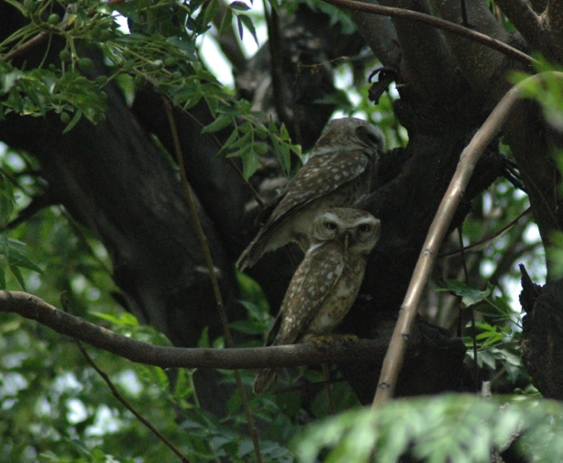

Fig. 1. The Spotted Owlets found sitting on dek trees.

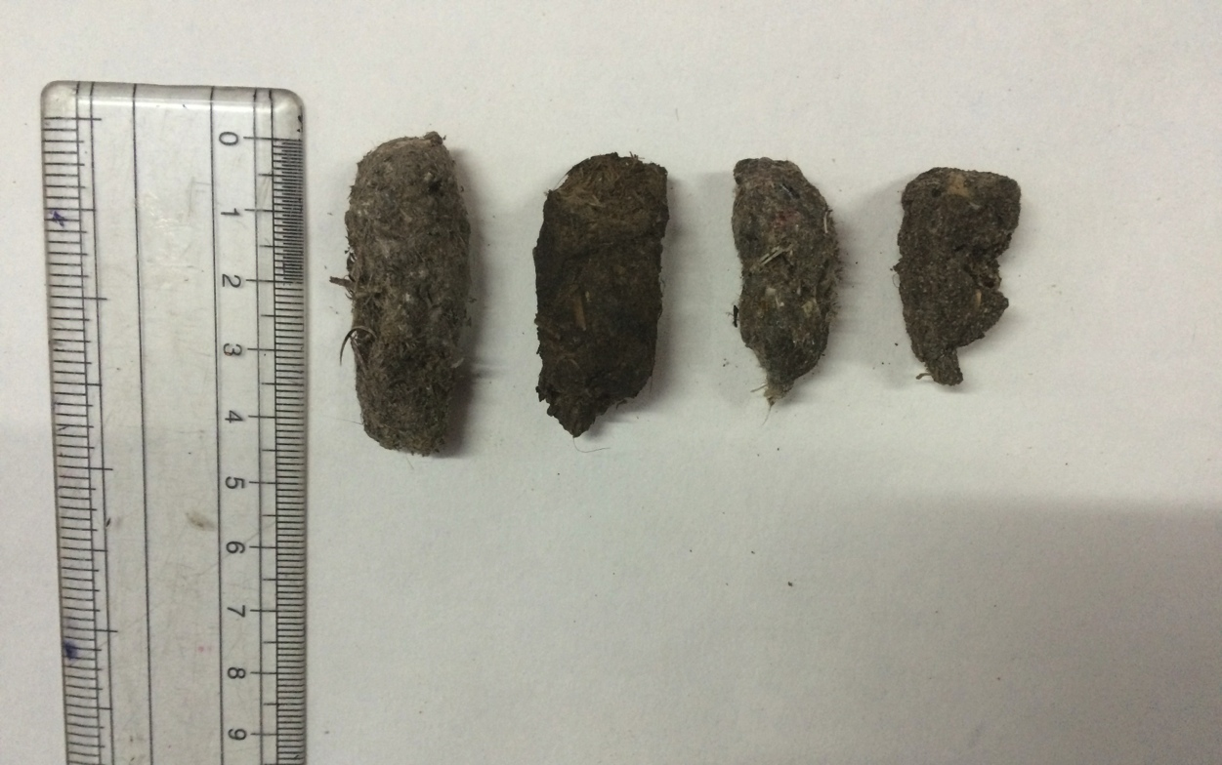

Fig. 2. Differently sized regurgitated pellets of Spotted Owlet collected
from different locations.

Fig. 3. Total number of prey items found in pellets of Spotted Owlet at all the eight locations.

Fig. 4. Percent prey composition in pellets of Spotted Owlet at all the eight locations.

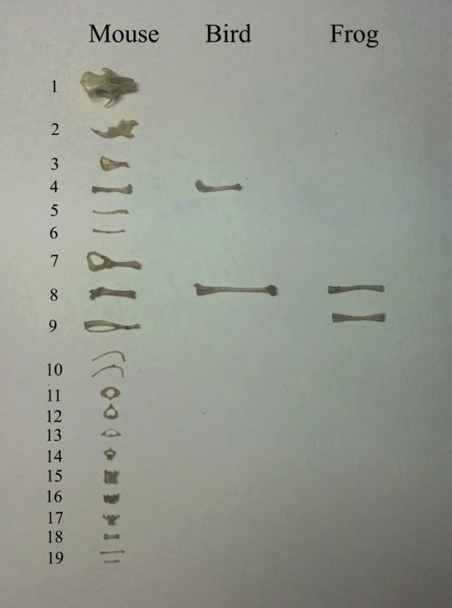
Fig. 5. The bones of mouse, bird and frog found in pellets of Spotted Owlet
1-Skull, 2-Lower jaw, 3-Shoulder blade, 4-Humerus, 5-Ulna, 6-Radius, 7-Hip bone, 8-Femur, 9-Tibia/Fibula, 10-Ribs, 11-Atlas, 12-Axis, 13-Cervical vertebra, 14-Thoracic vertebra, 15-Lumbar vertebra, 16-Sacral vertebra, 17, 18-Caudal vertebra, 19-Hand/Foot bones.

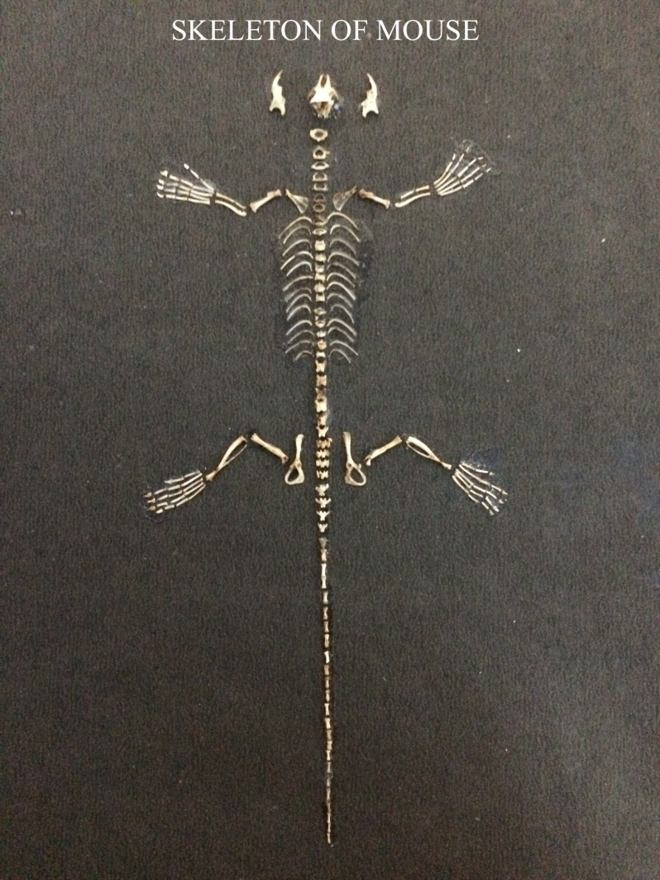

Fig. 6. Different bones of mouse found in pellets of Spotted Owlet and
arranged to show the complete skeleton.

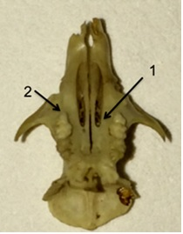

Fig. 7. Ventral view of skull material of field mouse, Mus booduga found in pellets of Spotted Owlet.
Arrow (1) anterior palatal foramina long, extending posteriorly between maxillary tooth rows.
Arrow (2) anterior accessory cusp on first upper molar tooth.

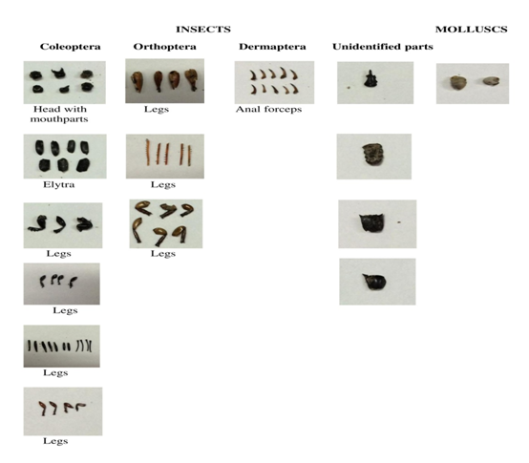
Fig. 8. The parts of insects of different orders found in pellets of Spotted Owlet.

