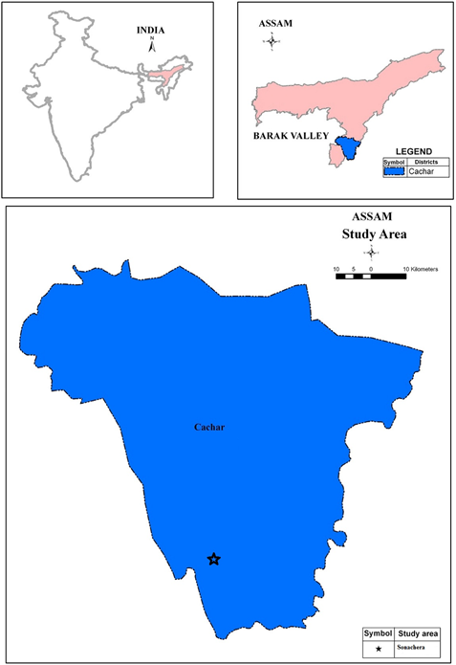
Figure 1.Map showing the location of the study area

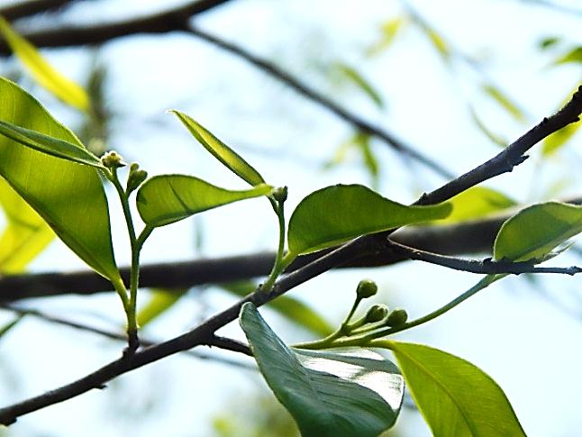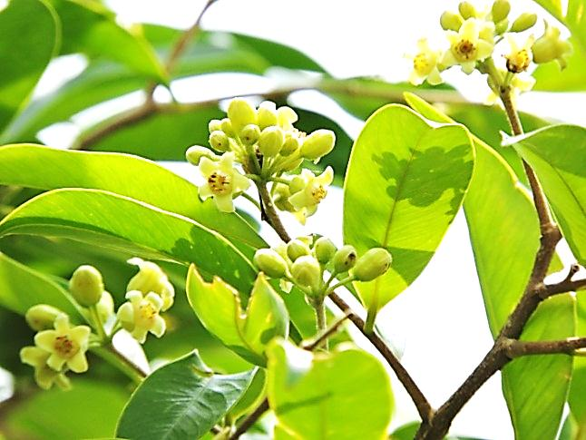
a
b
Image 1.Initiation of flowering Image 2. Fully bloom flower
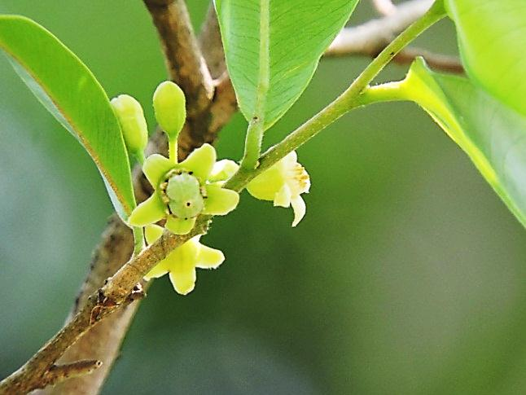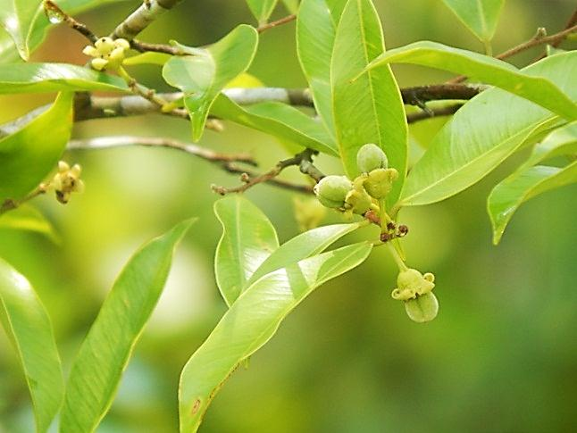
c
d
Image 3. Initiation of fruiting Image 4. Young fruit
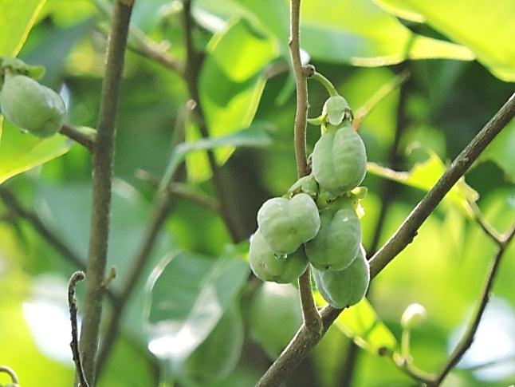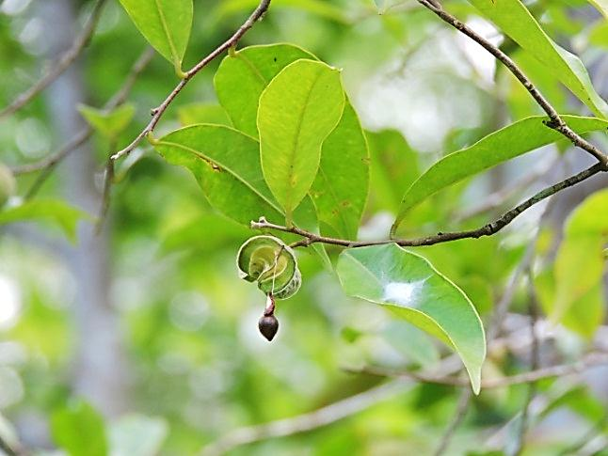
e
f
Image 5. Mature fruit Image 6. Dehiscence of fruit
Photo plate (a-f) showing the different phenophases of Aquilaria malaccensis
Table 1.Phenological patterns of A. malaccensis in relation to corresponding month and one month lag period of temperature and rainfall in Cachar district, Assam
 | Environmental factors
 | Spearman's rank correlation coefficients (r_{s})
Phenophases | Temperature (˚C) | Rainfall (mm)
 | 2013-14 2014-15 | 2013-14 2014-15
Leaf initiation | 0.694* 0.861** | (0.251NS) 0.528*
 | (0.125NS) (0.340NS) | (0.427 NS) (0.199NS)
Leaf-fall | -0.542* -0.661* | -0.521* (-0.444NS)
 | (-0.293NS) (-0.358NS) | (-0.174NS) (-0.358NS)
Flowering | 0.713** 0.684* | 0.713* 0.595*
 | (0.509 NS) (0.382NS) | 0.833** 0.683*
Fruiting | 0.721** 0.824** | 0.775 ** 0.662*
 | (0.518NS) 0.679* | 0.601* 0.833**
Values in parenthesis refer to one month lag period, **<0.01,*<0.05, NS: not significant

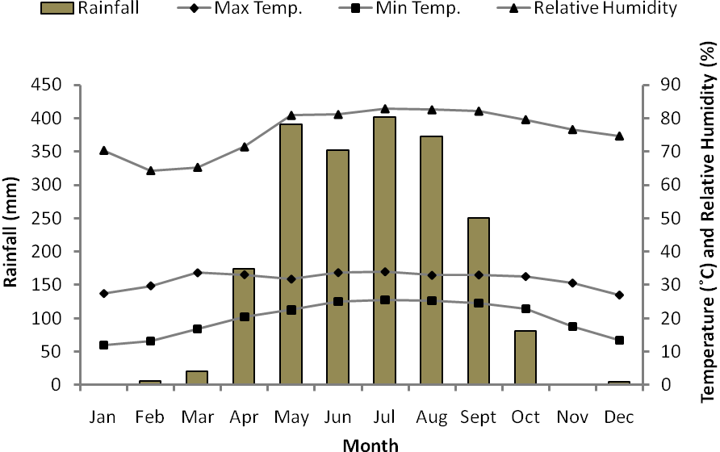
Figure 2.Ombrothermic diagram for the study period (2013-2015).Data collected from Tocklai Tea Research Association, Silcoorie, Silchar

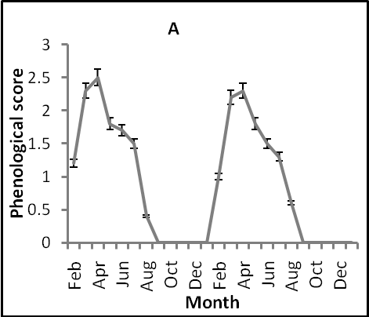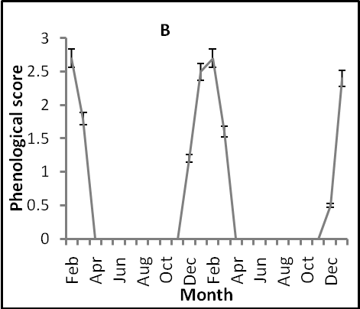
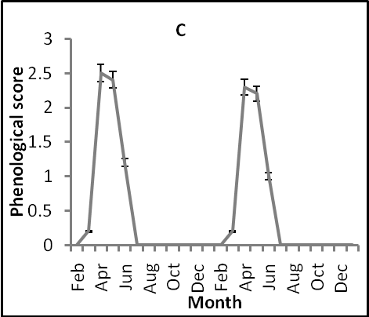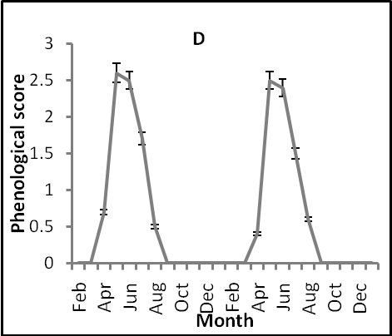
Figure 3. Periodicity of different phenophases of A. malaccensis throughout the two years (A) Leaf initiation (B) Leaf-fall (C) Flowering and (D) Fruiting. Error bar represents standard error

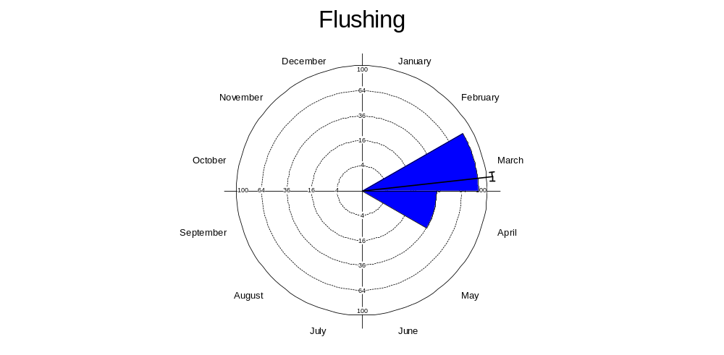

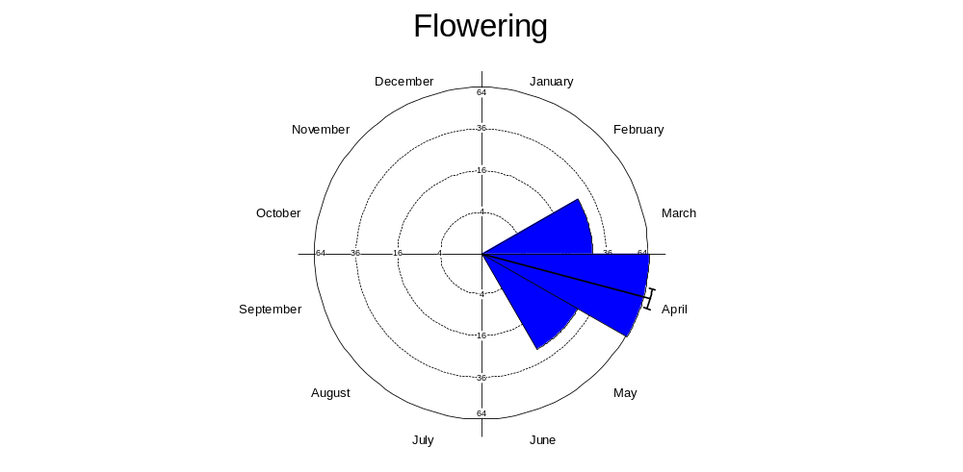
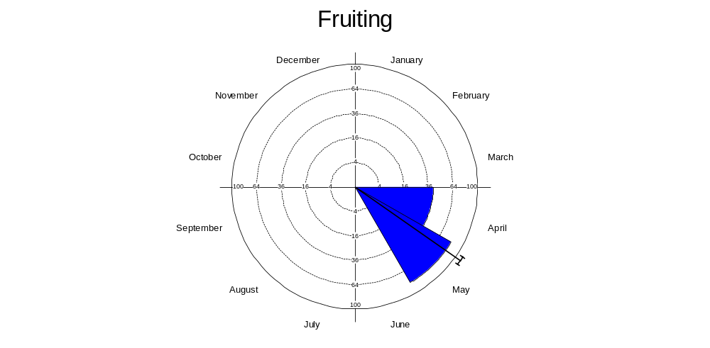
Figure 4.Circular histograms of the phenophases indicating the average date of A.malaccensis

Phenophases | F | M | A | M | J | J | A | S | O | N | D | J | F | M | A | M | J | J | A | S | O | N | D | J
l
Leaf initiation

Leaf-fall

Flowering

Fruiting

Low to moderate
Peak

No

Mature
Figure 5. Vegetative and reproductive phenological events and duration recognized in A. malaccensis in a secondary tropical forest of Cachar district, Assam

