BIOLOGY AND DISTRIBUTION OF PARNASSIUS MNEMOSYNE (LINNAEUS, 1758) A RARE SPECIES IN THE REPUBLIC OF MORDOVIA (RUSSIA)
A.B. Ruchin¹
¹Federal Government Funded Institution “Smidovich Mordovia State Nature Reserve”, Pushta Settlement, Temnikov Region, Mordovia Republic, e-mail: sasha_ruchin@rambler.ru

Abstract. The article presents data on findings of Clouded Apollo Parnassius mnemosyne in the Republic of Mordovia (Russia). In 2006-2016, more than 30 habitats of the species were identified. The increase in the number was observed in 2006-2011. Biotopes of the species, fodder plants of the imago, measures for species protection are described.

Key words: Clouded Apollo, Parnassius mnemosyne, abundance, ecology

Swallowtail butterflies (Papilionidae) belong to large, bright diurnal butterflies (Lepidoptera). They have well developed legs and notched hind wings. Because of their attractiveness, the populations of most species in many regions are threatened (van Swaay et al. 2012). There are 24 species of Swallowtails in Russia, five species of them occur in the forest-steppe zone of the Middle Volga region (Lvovsky & Morgun 2007). Clouded Apollo (Parnassius mnemosyne (Linnaeus, 1758)) was included in the Red Data Book of Russian Federation (2001). This beautiful butterfly is spread in many countries of Europe, some countries of Western and Central Asia (to the south of Western Siberia, the mountains of Central Asia, Afghanistan) (van Swaay et al., 2012). In Europe, it is classified as Near threatened (van Swaay et al. 2012).
The Republic of Mordovia is located in the center of the East European Plain between 42°11' and 46°45' east longitude and 53°38 ' and 55°11' north latitude in the southwestern periphery of the Volga basin in the interfluve of rivers Moksha and Sura. The territory includes forest and forest-steppe zones of Central Russia. The eastern part of Mordovia is located in the northwest of the Volga Upland and the western part in the Oka-Don lowland. In this regard, a variety of habitats is observed in the area of study. In the west, north-west and north of the country are common boreal coniferous and mixed forests under protection of Mordovia Nature Reserve (Ruchin & Egorov 2017). Broad-leaved forests cover the central and eastern parts. In the east and south-east predominate forest-steppe landscapes (Yamashkin, 1998).
Our own material was collected in the course of systematic research in 2006-2016. During this time, more than 200 geographical points, located in all the areas of the republic, were directly examined (usually, all possible biotopes). Visual censuses were performed while watching the feeding of imago butterflies.
We can observe fragmentation and shrinking of this species range due to anthropogenic transformations of landscapes and habitats in Europe and the densely populated areas of European Russia (Konvička & Kuras 1999; van Swaay et al. 2012). On the other hand, the species becomes more abundant in a number of European countries (Gorbach & Kabanen 2010, Liivamägi et al. 2013). In the Middle Volga region it is still noted as local, but inhabiting many sites, and sometimes rather numerous species (Sachkov 1988; Zolotukhin 1994; Goreslavets et al. 2001; Korb et al. 2017). At least 30 key habitats are known in Mordovia (Figure 1), but cenopopulations and breeding grounds stick to more compact areas.
According to the collections of Mordovia Nature Reserve Museum, Clouded Apollo was first found here in 1984. In recent years, it was observed in three other habitats in this specially protected area. According to observations, in Smolny National Park in 2006 the species was noted as single specimens (not more than 2-3 specimens) per 1 km, but in 2007 in the Lviv Forestry in the abandoned village (a large glade with wooden buildings) there was recorded 10 specimens per 1 km of the route, and in a small section of the forest edge – 18 specimens per single km (Ruchin & Kurmaeva 2010). In June 2007, a mass flight was recorded in the Bolshebereznikovsky District: local clusters were observed on a forest road, leading through mixed forest with a predominance of pine; in some of such clusters there were from 25 to 37 specimens per 1 km of the route; in some places (near the puddles on the road), these accumulations were even more significant (40-65 specimens / m2 were observed in different sections of the road). In broad-leaved forests (often of sprout origin), the population usually varies from 2 to 7 specimens per 1 km (sometimes up to 65 specimens per 1 km). Occasionally in large glades its number reached up to 22 specimens / km (Ruchin & Kurmaeva 2010). Thus, the number of Clouded Apollo finds and the species abundance were at highest rates in 2006-2011. Since 2012, its number has again decreased and does not exceed 1-3 specimens per 1 km of the route.
In Mordovia this species prefers broad-leaved forests (more often of sprouts origin), sometimes, pine broad-leaved forests. Habitats are well-warmed forest glades with mixed herbs, forest fringes, cuttings, sides of forest roads (Fig. 2). The forage plant of caterpillars in the region is Corydalis solida (L.). Caterpillars pupate in a cocoon on the ground among vegetation. Egg winters with a formed caterpillar inside. Butterflies fly from mid-May to early July; they have a distinguishing slow planning flight; feed on flowers of various herbs; when the species is abundant butterflies become rather daring. According to our observations, imagoes feed on Fragaria viridis L., Lathyrus pisiformis L., Taraxacum officinale L., Leucanthemum vulgare Lam., Stellaria nemorum L., Ranunculus polyanthemus L., Geranium pratense L., Achillea millefolium L. and Viola mirabilis L.
This species is rather stenotopic and local, it is not prone to dispersal, and it disappears at significant disturbances of existing habitats. In case of outbreaks, butterflies disperse over isolated habitats, but the permanent colonization of new habitats and migrations through agrocenoses are not common for the species; most of the cenopopulations from localized sites are mostly, or practically, isolated. At all stages of development the species is vulnerable to disturbances in soil cover and burnt areas. The decrease in the fodder base of caterpillars can be caused by the destruction of fodder plants, especially by grazing, while fodder base of butterflies suffers from damage to vegetation and hay harvesting in flowering glades.
There were no special protection measures for Clouded Apollo taken in the republic. In the future, it is advisable to limit the economic activities in the habitats of the species: to protect Corydalis solida, plants with crimson flowers, from damage; prohibit making fires outside the designated areas, cultivation of forest edges and glades, machinery movement outside of the roads, cutting trees and haymaking in June; to limit grazing by the end of June, excavation and trampling of grass; to prohibit chemical processing in a radius of at least 200 m from the species habitats. Prevent overgrowth of habitats by bush and weed. At least 15 populations live in the territories of Mordovia Reserve, Smolny National Park and at nature monuments "Oak Grove", "Khanenevskaya Grove", "Tarhanovskaya Dacha" and "Birch Grove".

References
Gorbach, V.V. & D.N. Kabanen (2010). Spatial organization of the Clouded Apollo population (Parnassius mnemosyne) in Onega Lake Basin. Entomological Review 90: 11–22.
Goreslavets, I.N., I.V. Dyuzhaeva, Y.P. Krasnobayev, V.I. Kupayev, E.K. Liashenko, S.A. Sachkov, Y.V. Sachkova & T.A. Trofimova (2001). Scale-winged insects (Lepidoptera) in the Red Data Book of the Samara Region. Samarskaya Luka 11: 170–200.
Konvička, M. & T. Kuras (1999). Population structure, behaviour and selection of oviposition sites of an endangered butterfly, Parnassius mnemosyne, in Litovelské Pomoraví, Czech Republic. Journal of Insect Conservation 3: 211–223.
Korb, S.K., D.A. Pogozhin, A.A. Zatakovoy & R.E. Talyak (2017). The butterfly fauna of the Nizhny Novgorod Region inventarisation experience (Insecta: Lepidoptera) and its use for the regional Red Data Book building. Nature Conservation Research 2 (1): 57–72.
Liivamägi, A., V. Kuusemets, J. Luig & K. Kask (2013). Changes in the distribution of Clouded Apollo Parnassius mnemosyne (Lepidoptera: Papilionidae) in Estonia. Entomologica Fennica 24: 186–192.
Lvovsky, A.L. & D.V. Morgun (2007). Lepidoptera of Eastern Europe. Association of scientific publications of KMK, Moscow, 443 pp.
Red Data Book of Russian Federation (2001). Animals. Astrel, Moscow, 862 pp.
Ruchin, A.B. & L.V.Egorov (2017). Overview of insect species included in the Red Data Book of Russian Federation in the Mordovia State Nature Reserve. Nature Conservation Research 2(1): 2–9; DOI: 10.24189/ncr.2017.016
Ruchin, A.B. & D.K. Kurmaeva (2010). On rare insects of Mordovia included in the Red Book of Russian Federation. Entomological Review 90(6): 712–717.
Sachkov, S.A. (1988). Lepidoptera of Kuibyshev Region entered into the Red Data Book of the USSR, and their protection. Protection of animals in the Middle Volga region (Collection of articles): 43-51.
van Swaay, C., C. Collins, G. Dušej, D. Maes, M.L. Munguira, L. Rakosy, N. Ryrholm, M. Šašić, J. Settele, J.A. Thomas, R. Verovnik, T. Verstrael, M. Warren, M. Wiemers & I. Wynhoff (2012). Dos and don'ts for butterflies of the habitats directive of the European Union. Nature Conservation 1: 73–153; doi: 10.3897/natureconservation.1.2786
Yamashkin, A.A. (1998). Physical and geographical conditions of the Republic Mordovia. Publisher of the Mordovia State University, Saransk, 156 pp.
Zolotukhin, V.V. (1994). Materials on the fauna of Lepidoptera in the Ulyanovsk region. Part 1. Rhopalocera. The Nature of Ulianovsk Region 5: 60–81.

Fig. 1. Places of finds of Clouded Apollo in the Republic of Mordovia (highlighted in red).
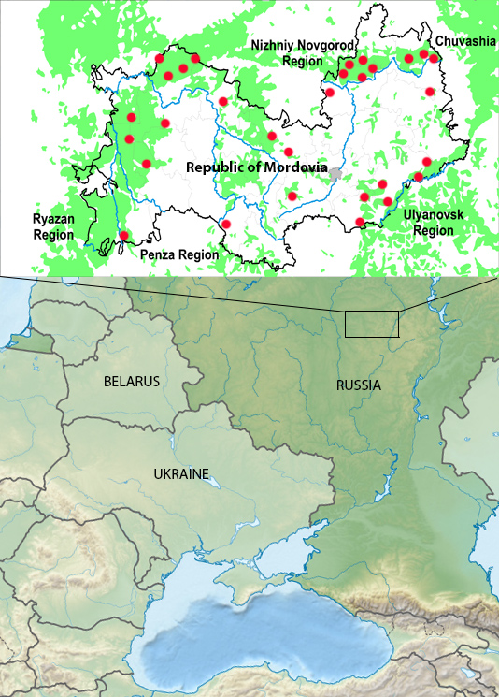
Figure 1

Fig. 2. Clouded Apollo butterfly and habitats of the species: A - imago (Pajgarm, Ruzaevsky district, 17.v.2007); B - biotope (Svetotekhnika, Ardatovsky district, 18.v.2008); C - biotope (Tarkhany, Temnikovsky district, 05.vi.2009); D - biotope (Vindrej, Torbeevsky district,6.vi.2008).
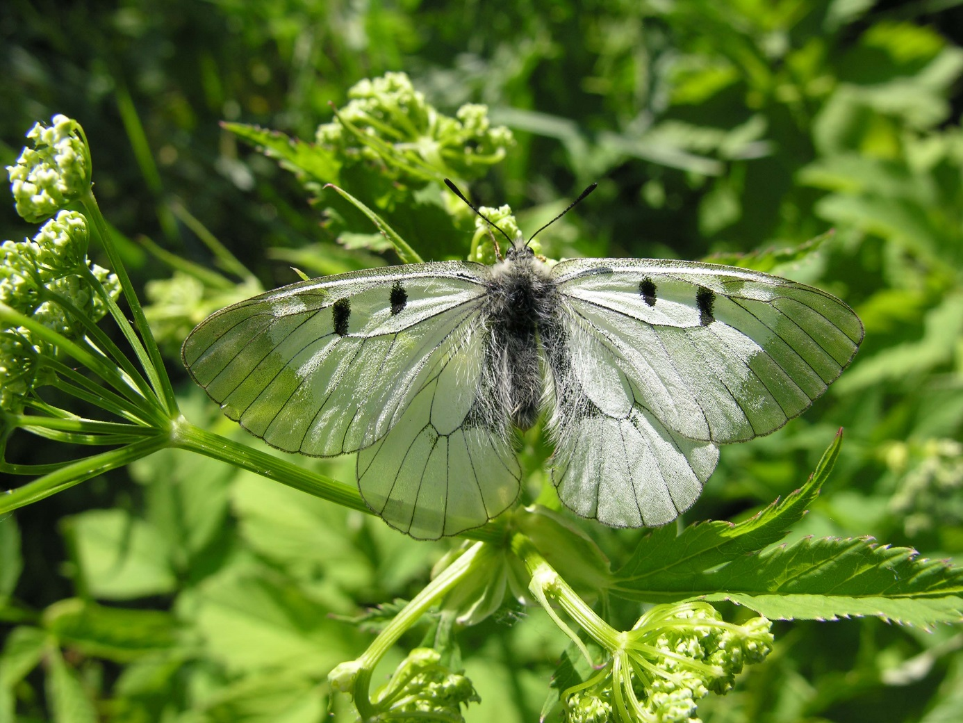
A- imago (Pajgarm, Ruzaevsky district, 17.v.2007). Photo by Alexander Ruchin
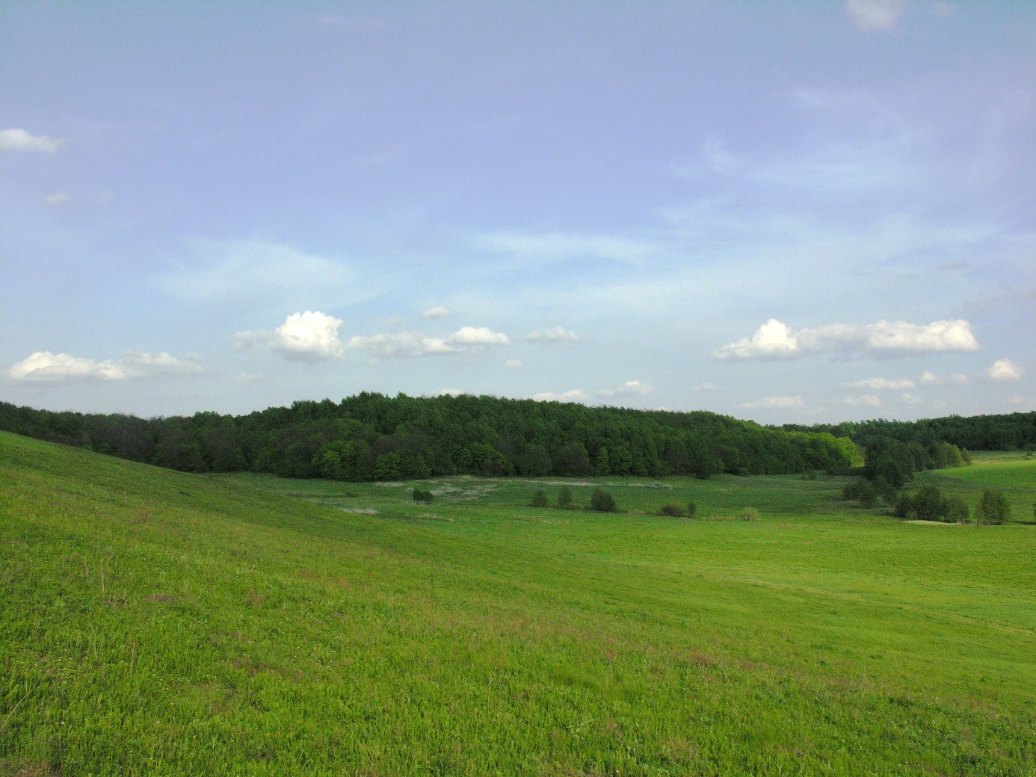
B- biotope (Svetotekhnika, Ardatovsky district, 18.v.2008). Photo by Alexander Ruchin.
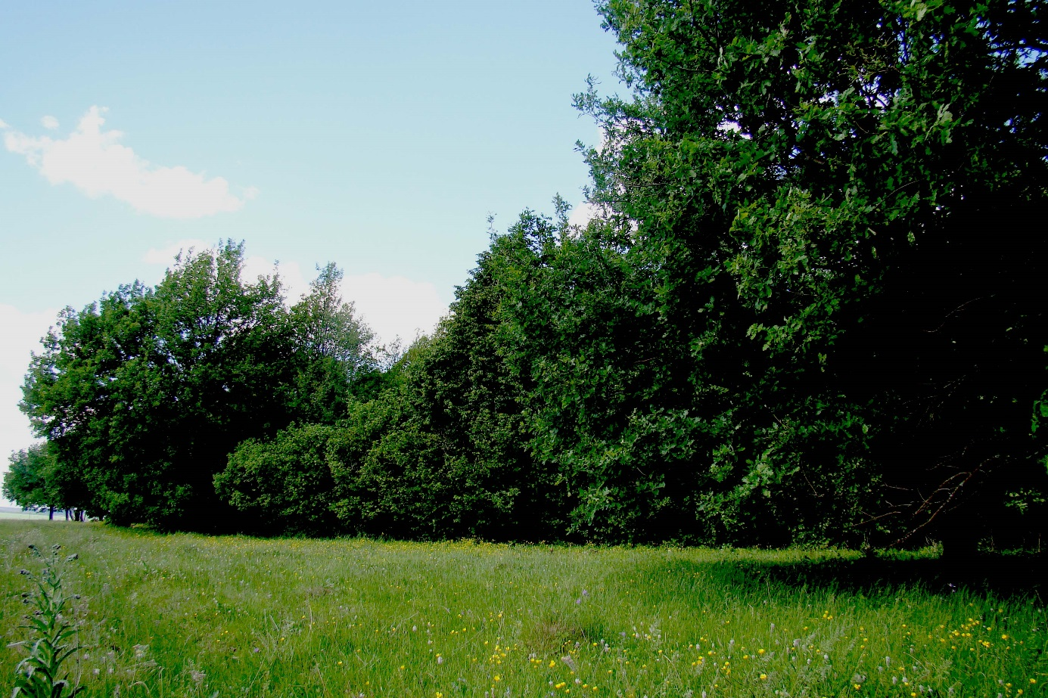
C- biotope (Svetotekhnika, Ardatovsky district, 18.v.2008). Photo by Alexander Ruchin.
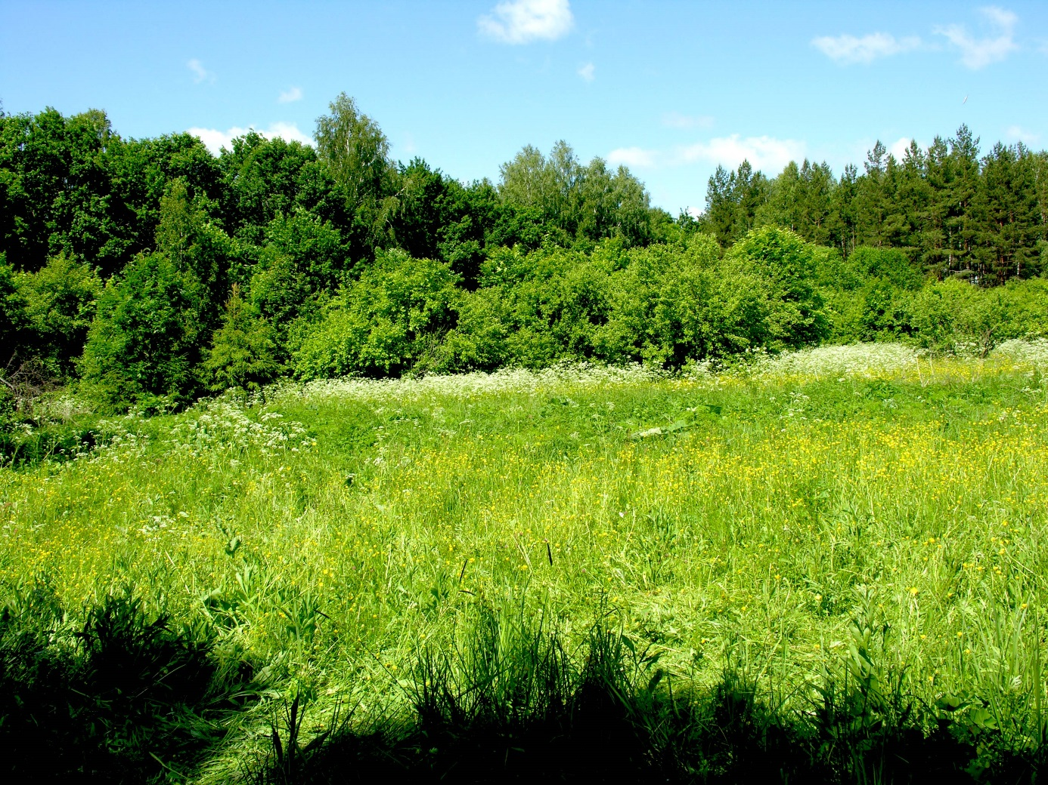
D - biotope (Vindrej, Torbeevsky district,6.vi.2008). Photo by Alexander Ruchin..

